
a
Company
Logotype

Cone Beam Computed Tomography- Report



Porur Dental X-rays & CBCT

Patient Name : Mrs. Hemalatha | Date of Report : 12.01.2025
Age/ Gender : 39 years/ Female | Region of Interest : CBCT Full Skull
Referring doctor: Dr. Selva Ganesh | Indication : Implant assessment
Clinical Notes: Nil
PATIENT INFORMATION

CBCT- Full Skull provided
CBCT – IMAGE DETAILS

RADIOGRAPHIC INTERPRETATION

- Completely missing crown and root portion in relation to 13, 48.
- The maxillary and mandibular alveolar ridge is present with normal trabecular pattern.
- The tooth 33 appears to lie below the occlusal plane and between the radicular portion of 31 and 32. The occlusal plane of this tooth appears to be in line with the cementoenamel junction of 32 and 33 appears to lie labially.
- Root stumps: 38
- Presence of hyperdense orthodontic appliance in relation to maxillary and mandibular teeth.

IMPLANT ASSESSMENT
 | 23 region
Sub-Crestal | 4.5
Mid- Crestal | 4.7
Distance between the alveolar ridge and Floor of the Nasal cavity  (in mm) | 19.7

RADIOGRAPHIC IMPRESSION

- Partially edentulous maxillary arch.
- Impacted 33
- Root stumps: 38

Kindly correlate with clinical findings


IMAGES FOR REFERENCE

RECONSTRUCTED PANORAMIC VIEW

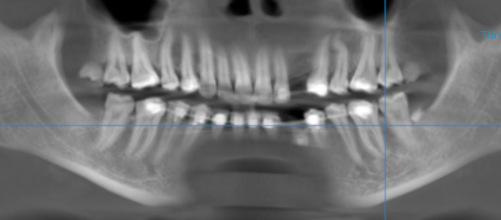

3-DIMENSIONAL VIEW

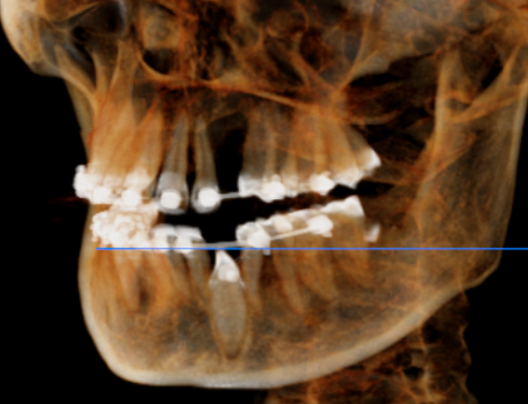

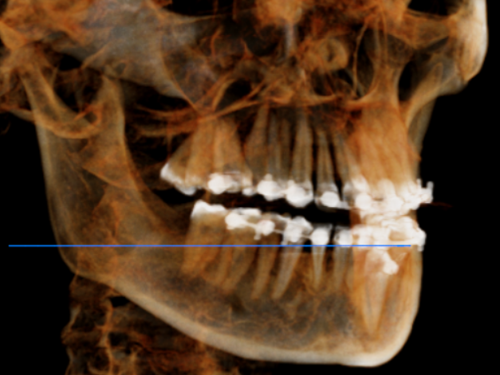

CROSS SECTIONAL VIEW

23 region | 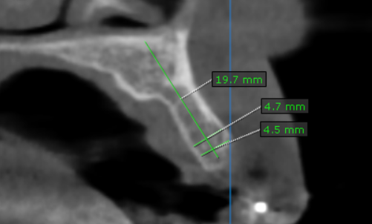
33 region | 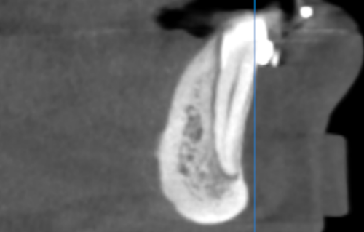

**** End of report ****

